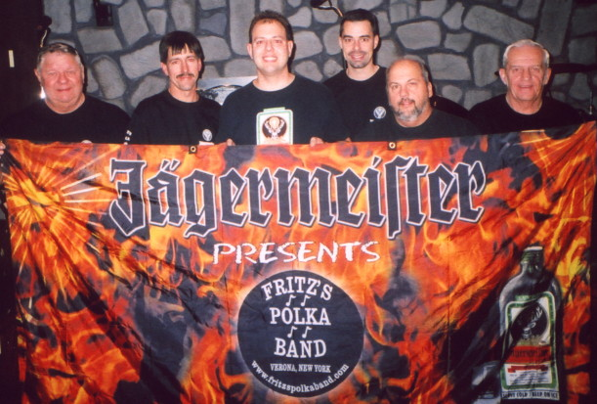
www.fritzspolkaband.com
www.fritzspolkaband.net
www.jagermusic.com
October 15, 2005: Norwich Oktoberfest at VFW------Norwich, NY:
It’s a good thing we were playing indoors today, as the weather was rainy again. This was our third year performing for the Oktoberfest at the VFW, and once again, it was a great time. Doreen and her crew treat us great, and they host a nice Oktoberfest. Here’s the set list from today’s cold, but festive gig:

1st set | 2nd set | 3rd set
Here Is Fritz’s Polka Band / There’s A Party | Fire Up! | Austrian Wedding Dance
Stand And Sing Ein Prosit | Memphis | Too Fat Polka (requested)
Mountain Flower Waltz | Big Bang Polka (button-box tune) | Beautiful Rose Waltz
It’s Jager Time | Wooden Shoe Polka (button-box tune) | In Heaven There Is No Beer (requested)
Green, Green Grass Of Home | Marian’s Waltz (button-box tune) | Joann Polka
Polka Time In The Morning | Bialczak’s Polka (button-box tune) | I Just Want To Dance With You
Euclid Vet’s Polka | Chime Bells (requested Tom & Gabe duet) | Springtime Polka
In Norwich, It’s An Oktoberfest | Make The World Go Away | Old Habits
Havin’ Fun | Pennsylvania Polka (requested) | Ricky’s Polka
Just Because Polka (requested) | Grandparent’s Polka | Red Raven Polka
Scherz’s Polka | I’m Sorry Waltz | Nobody’s Darling But Mine
Take These Chains From My Heart | North, South, East, West | The Trip Is Over
Clarinet Polka |  | It’s Goodbye To You

Next up, tonight we play at the German Club In Binghamton, NY for another Oktoberfest at 7pm……..

