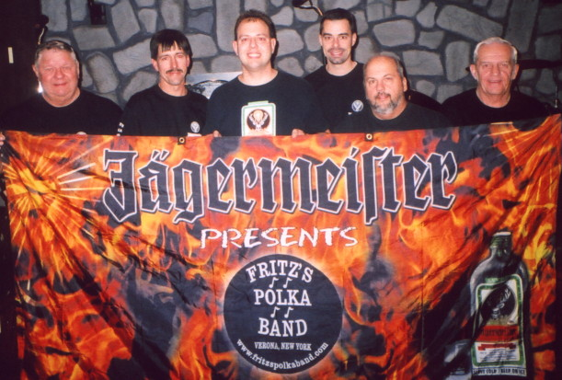
www.fritzspolkaband.com
www.fritzspolkaband.net
www.jagermusic.com
September 17, 2005: The Great Escape---Lake George, NY:
It was great to return to The Great Escape, as last year we had such a blast performing there. This year, we’re playing there two weekends instead of one, which is just fine with us, as the folks at The Great Escape treat us really well, and there’s always a bunch of fun-loving people in attendance, including new friends like Erica, Justin, and Jean. Unlike last year, we didn’t play on the Saturday evening portion of the Oktoberfest. Quite a few people stopped by and told us they wished we were playing Saturday night, too. We were pleased to hear that they loved FPB!!! Here’s the list of tunes we did today:

1st set | 2nd set | 3rd set | 4th set
Here Is Fritz’s Polka Band / The Party’s Just Begun / We Like To Play For You | Skippy’s Polka (button-box tune) | Happy Birthday (to Erica) / Happy Birthday Polka | Happy Birthday (to Katie)
It’s Jager Time | Tony’s Polka (button-box tune) | Stretch It Out | FPB On Tap
Sailor | Chime Bells (Tom solo) | Tennessee Waltz | Scherz’s Polka
I Can’t Help It | Polka Time In The Morning | Rautenberg’s Oberek | Chicken Dance (requested)
Nancy’s Polka | Green, Green Grass Of Home | Square Green Bottle | Your Cheating Heart
North, South, East, West | Songs Of Yesterday | Drinking Champagne | John’s Polka
 | Hey Little Sweetheart | Ricky’s Polka | Chocolate Ice Cream Cone (Tom solo)
 | Helena Polka | Grandparent’s Polka | All Night Long / E – I - O
Next up, tomorrow we crank it up once again at The Great Escape!

