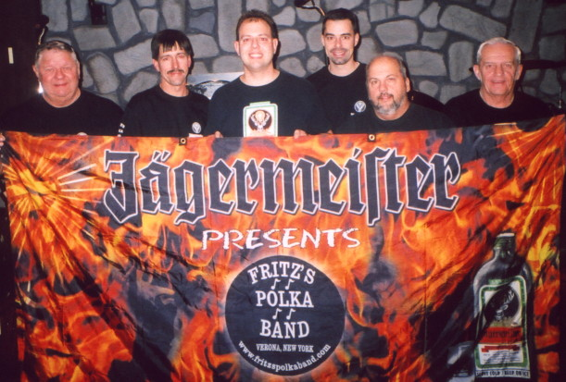
www.fritzspolkaband.com
www.fritzspolkaband.net
www.jagermusic.com

July 14, 2005: World in the Square at Hanover Square---Syracuse, NY

On our way to the gig, we were worried it might get rained out. Thankfully, the rain held and we were able to finish the gig before the rain came down. Here’s our set list from today’s hot & humid, 90 minute gig:
- Here Is Fritz’s Polka Band / The Party’s Just Begun / I Want To Call You Sweetheart
- It’s Jager Time
- La De Da Oberek
- Old Habits
- Chicagoland Twirl
- The Wutch
- Help Me Make It Through The Night
- Baby Doll Polka
- Square Green Bottle
- Make The World Go Away
- Another Polka Dance
- Bubble’s Polka
- So Far Away
- Fire Up!
- Memphis
- For What It’s Worth
- Tuffy’s Polka (button-box tune)
- Skippy’s Polka (button-box tune)
- Tony’s Polka (button-box tune)
- Don’t Close Your Eyes
- Side By Side
- Save The Last Dance For Me
- Bye, Bye Baby

Next up, we crank it up tonight at the Kallet Theatre in Oneida, NY at 6pm……….

