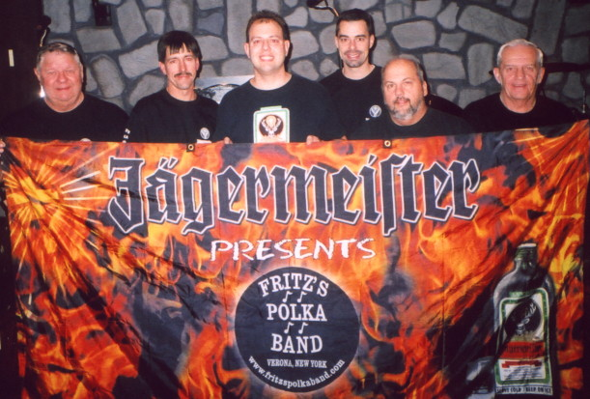
www.fritzspolkaband.com
www.fritzspolkaband.net
www.jagermusic.com

July 2, 2005: Birthday Party for Jim Price at Drumlin’s County Club----Syracuse, NY:
Before we even started today, we knew this would be a great gig, as Jim’s wife told us that they came to Chittenango a few weeks ago to see us perform at the Canal Boat Museum, and absolutely loved FPB! So, that was cool. This was a surprise party, too, so when Jim came up the stairs and entered the room we were set up in, it was great to see the joy and look of surprise on his face. Here’s the list of tunes we did at this gig:

1st set: Give Polka Music A Chance, Just Because Polka, Blue Skirt Waltz, Release Me, Chicagoland Twirl, I Left My Heart In San Francisco, West Leyden Waltz, and Bubble’s Polka.

2nd set: Give A Kiss Waltz, Clarinet Polka (requested), Grandparent’s Polka, You Are My One True Love, La De Da Oberek (requested), Help Me Make It Through The Night, Nancy’s Polka, Forever And Ever, Your Cheating Heart, Blind Date Polka, Save The Last Dance For Me, All Night Long, Happy Birthday (to Jim), and Happy Birthday Polka.

After we got packed up, Rick and I cruised to Saratoga Springs for the Dave Matthews Band concert at SPAC. Next up for FPB, we perform at the Oswego County Fair at 4pm on July 4th….

