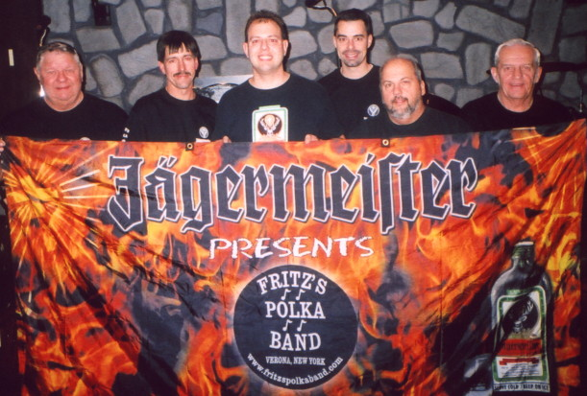
www.fritzspolkaband.com
www.fritzspolkaband.net
www.jagermusic.com

June 12, 2005: Benefit for Jim & Cheryl Youngs-----Boonville, NY:
This event was held at the Boonville VFW. We were glad to take part, as Jim & Cheryl and their five kids had their house burn down recently, and we wanted to step up and help them out, as we’ve known Jim’s father, Kenny, for many, many years. When we arrived the air conditioning felt great. Once we had the equipment unloaded and the people packed the room, it was very hot & humid. As always, FPB rocked the place. Here are the tunes we did today:

1st set: Here Is Fritz’s Polka Band / Can’t Get Enough Of Polka Music, FPB On Tap, Crystal Chandelier, Stretch It Out, Boonville Polka, West Leyden Waltz, No Beer Today, It’s Jager Time, 1982, Old Habits, Side By Side, Grandparent’s Polka, Silver Wings, and Good Hearted Woman.

2nd set: Big Bang Polka (button-box tune), Marian’s Waltz (button-box tune), Gabe’s Polka (button-box tune), I’d Love You All Over Again, A Song For Mother, Square Green Bottle, Baby Doll Polka, Scherz’s Polka, Wonderful Tonight, and The Wutch (requested).

Next up, we play on Friday, June 17th at The Gathering Place in New Hartford, NY at 7pm………..

