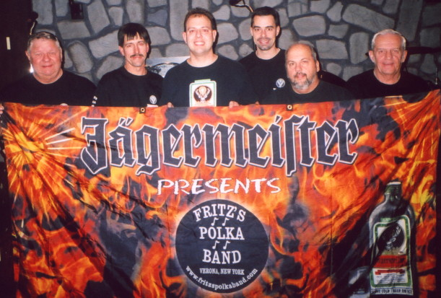
www.fritzspolkaband.com
www.fritzspolkaband.net
www.jagermusic.com

June 3, 2005: Sammy Awards at “Taste of Syracuse” at Clinton Square-----Syracuse, NY:

This was the first time that FPB was booked to perform at this great event. It was easy to play at a gig like this, as the stage was big, the lights were cool, and the sound was great from the stage. The place was packed, and we were jacked up for this gig. The guys in FPB really sounded special tonight! We tipped some Jager, both before & after the gig. We even had our friend, Joe Whiting, jam on a tune with us! Here’s the set list from tonight’s cranking performance: Here Is Fritz’s Polka Band/Give Polka Music A Chance ‘98/FPB On Tap, It’s Jager Time, Lay Down Beside Me, Polka Time In The Morning, Your Cheating Heart, The Wutch, Nancy’s Polka, Margaritaville, Mikey J’s Polka (button-box tune), Bialczak’s Polka (button-box tune), Green, Green Grass Of Home, Square Green Bottle (special guest, Joe Whiting jammed on saxophone with FPB), Fire Up!, For What It’s Worth, All Night Long/E-I-O.

Next up, we return to Clinton Square in Syracuse, NY for the Syracuse Polish Festival on June 10th…..

